1. **Write a Java program to print "Hello, World!" to the console.**

**Code-**

package demo1;

public class hello {

public static void main(String[] args) {

// **TODO** Auto-generated method stub

System.***out***.println("hello world");

}

}

**Output -**

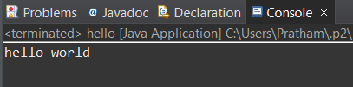

1. **Write a program to find the sum of two numbers entered by the user.**

**Code-**

package demo1;

import java.util.Scanner;

public class add {

public static void main(String[] args) {

// **TODO** Auto-generated method stub

int a,b; // Declare variables to store the numbers

Scanner s = new Scanner (System.***in***);

System.***out***.println("Enter the 1st number: ");

a = s.nextInt();

System.***out***.println("Enter the 2nd number: ");

b = s.nextInt();

int sum =a+b; // Add the two number

System.***out***.println("The sum of two number is: " + sum);

s.close(); // Close the scanner

}

}

**Output-**

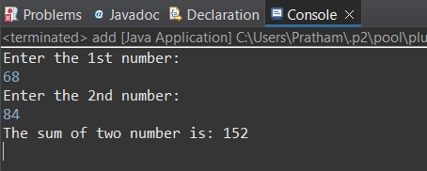

1. **Write a Java program to check whether a given number is even or odd.**

**Code-**

package demo1;

import java.util.Scanner;

public class EvenOdd {

public static void main(String[] args) {

// **TODO** Auto-generated method stub

Scanner scanner = new Scanner(System.***in***); // Create Scanner object

System.***out***.println("Enter an integer: ");

int number = scanner.nextInt();

if(number % 2 == 0) {

System.***out***.println(number + "is even.");

} else {

System.***out***.println(number + "is odd.");

}

scanner.close();

}

}

**Output-**

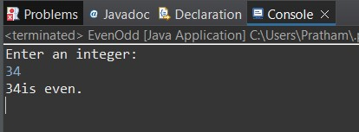

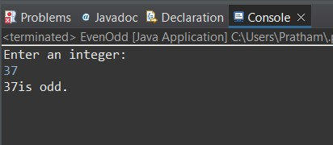

1. **Write a program to calculate the factorial of a number using recursion.**

**Code-**

package demo1;

import java.util.Scanner;

public class Factorial {

public static int calculateFactorial(int number) {

if (number == 0) {

return 1; // Base case: Factorial of 0 is 1

} else {

return number * *calculateFactorial*(number - 1); // Recursive call

}

}

public static void main(String[] args) {

Scanner scanner = new Scanner(System.***in***);

System.***out***.print("Enter a non-negative integer: ");

int number = scanner.nextInt();

if (number < 0) {

System.***out***.println("Factorial is not defined for negative numbers.");

} else {

int factorial = *calculateFactorial*(number);

System.***out***.println("The factorial of " + number + " is " + factorial);

}

scanner.close();

}

}

**Output-**

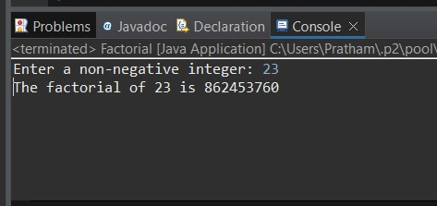

1. **Write a java program to find greatest of 2 numbers.**

**Code-**

package demo1;

import java.util.Scanner;

public class greatnumber {

public static void main(String[] args) {

Scanner sc = new Scanner(System.***in***);

System.***out***.println("Enter 1st number : ");

int num1 = sc.nextInt();

System.***out***.println("Enter 2nd number : ");

int num2 = sc.nextInt();

int greatest = (num1 > num2) ? num1 :num2;

System.***out***.println("The Greatest number is : " + greatest);

sc.close();

// **TODO** Auto-generated method stub

}

}

**Output-**

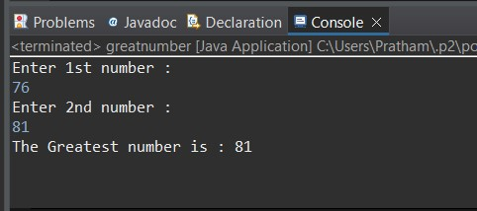

1. **Write a program to implement a basic calculator that takes input as a string expression and evaluates it.**

**Code-**

package demo1;

import java.util.Scanner;

public class Calculator {

public static void main(String[] args) {

Scanner sc = new Scanner(System.***in***);

System.***out***.print("Enter an expression: ");

String expression = sc.nextLine();

double result = *evaluateExpression*(expression);

System.***out***.println("Result: " + result);

}

public static double evaluateExpression(String expression) {

// Implement your expression evaluation logic here

// For simplicity, let's assume the expression is in the form of "operand1 operator operand2"

String[] parts = expression.split(" ");

double operand1 = Double.*parseDouble*(parts[0]);

String operator = parts[1];

double operand2 = Double.*parseDouble*(parts[2]);

double result = 0;

switch (operator) {

case "+":

result = operand1 + operand2;

break;

case "-":

result = operand1 - operand2;

break;

case "*":

result = operand1 * operand2;

break;

case "/":

result = operand1 / operand2;

break;

default:

System.***out***.println("Invalid operator");

}

return result;

}

}

**7. Create a Java program that compares two numbers and prints the larger one.**

**Code-**

package demo1;

import java.util.Scanner;

public class Largenumber {

public static void main (String args[]) {

Scanner s = new Scanner(System.***in***);

System.***out***.println("Enter 1st number : ");

int num1 = s.nextInt();

System.***out***.println("Enter 2nd number : ");

int num2 = s.nextInt();

if(num1 > num2) {

System.***out***.println("The larger number is : " +num1);

}

if(num2 > num1) {

System.***out***.println("The larger number is : " +num2);

}

else {

System.***out***.println("Both numbers are equal");

}

s.close();

}

}

**Output-**

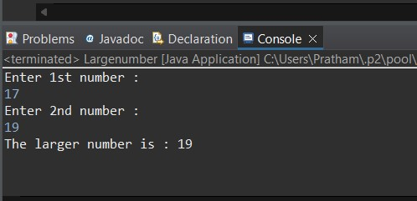

**8.Write a Java program that takes an age input from the user and determines if they are eligible to vote (considering the legal voting age).**

**Code-**

package demo1;

import java.util.Scanner;

public class Vote {

public static void main(String[] args) {

Scanner s = new Scanner(System.***in***);

System.***out***.println("Enter your age : ");

int age = s.nextInt();

if (age >= 18) {

System.***out***.println("You are eligible to vote.");

}

else {

System.***out***.println("You are not eligible to vote.");

}

s.close();

// **TODO** Auto-generated method stub

}

}

**Output-**

